Grade 3
Hello World

Description: | Students will:  Type the words Hello World and/or draw the letters with paint tools.  Make scripts using forward, turn and stamp tiles.  Change the numbers in the forward and turn tiles.  Experiment with controlling the patterns that form.  Apply knowledge of angles such as 30, 45, 90, 180, and 360.  Make a reset script with x, y, and heading tiles.  Make new scripts replacing the forward tile with x increase by and decrease by functions.  Compare patterns with these scripts and the earlier scripts.  Discuss their favorite patterns and which script and numbers were used to make it.  Observe patterns on nearby screens, estimate the turn by values.  Add random number tiles to all of these scripts changing one tile for each experiment.
Project View | 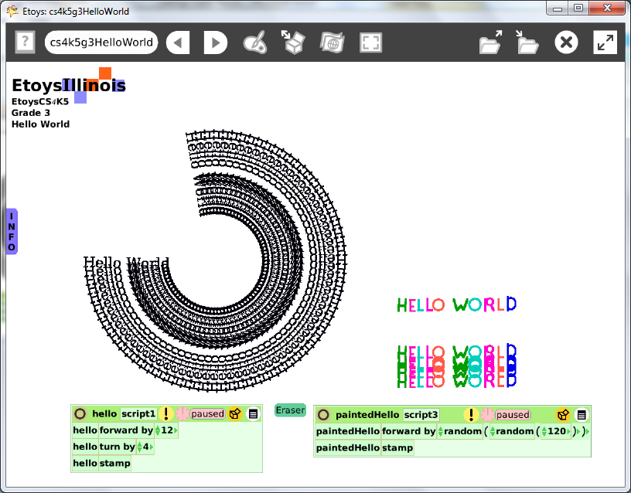
Subject: | Math
Etoys Quick Guides | Click the question mark in Etoys to open the set of interactive tutorials for basic tools and techniques.
Vocabulary: | Forward, turn, increase, decrease, X axis, y axis, heading, random number generator, angles, degrees
Lesson 1:  Supplies: Text  Script Tiles: Forward and Turn  Script Tiles: Stamp  Script Tiles: Pen Use  Navigator Bar: Keep Find Projects | Type Hello World and create a script with the tiles: forward by, turn by, and stamp.  Make a script with the clear all pen trails tile. The top border of the scriptor has a white menu command: make a button to fire this script. Put the button on the screen in a convenient place. Open a halo for the button and use its white menu command “change label” to add a meaningful name to the button.  Change the numbers and it changes the pattern. Experiment. Describe, discuss, and share favorites with others.  Open a viewer for the world and choose a new background color.  Some students may want to start their experiment at the same place and with the same heading each time. Make a reset script with x, y and heading tiles. Use its white menu, make a button, and label it Reset.  Paint the words Hello World and create a set of scripts for it.  Give students ample time to experiment with all of these scripts.  Keep the project. Call it: nameHelloWorld e.g. KateHelloWorld
Lesson 2: | Change the turn by number to these angles which students will be familiar with from math curriculum: 30, 45, 90, 180, and 360 degrees.  Experiment with the effect of changing each of these angles by increasing or decreasing by 1. Discuss.  Give students time to experiment and to share their favorite number combinations with their near neighbors or with the class.  Keep the project.
Lesson 3:  Script Tiles: X and Y Tiles | Create a new script for the painted words with: X, turn by, and stamp tiles.  Click on the small arrow in the X tile to open a menu with: increase by, decrease by and multiply. Choose an option: experiment and discuss.  Give students time to make many patterns. Ask students to remember combinations of numbers that make a favorite pattern.
Lesson 4:  Script Tiles: Random Numbers | Add random number generator tiles to any and all of the tiles in previous scripts and experiment with effects.  Give students time to experiment. After many experiments give students time to look at patterns on their neighbor’s screens; can they can estimate the numbers that made it.
Standards: | Common Core Standards  Mathematics 3.MD.3.4  Bloom’s Taxonomy/Cognitive Domain:  Knowledge: knows  Comprehension: estimates, gives examples, explains  Application: uses  Analysis: analyzes, compares  Evaluation: explains  NETS  3. a  4. a, b, c, d
Resources: | Etoys Help Quick Guides: always available in Etoys. Open Etoys and click the question mark to open a set of interactive tutorials of basic tools and techniques.  www.etoysillinois.org projects, lesson plans, software download  www.mste.Illinois.org more math, science, and technology resources  www.corestandards.org Common Core Standards  www.squeakland.org software and Etoys projects  www.nctm.org Standards and Focal Points for each grade level
kh January 2011

